Lecture Notes 5:  
  
DNS: Domain Name Server  
  
Domain name system

Domain name system, commonly known as DNS, is a system that averts the need to remember long IP addresses to visit a website by mapping easy-to-remember domain names to IP addresses.

amazon.com is a domain name that is mapped to its unique IP address by the DNS so that we are not expected to type in the IP address of amazon.com into our browsers every time we visit that website.

How does a domain name system work?

When a user types in the URL of the website in their browser and hits enter, this event is known as DNS querying.

Four key components, or a group of servers, make up the DNS infrastructure. These are:

* DNS Recursive nameserver aka DNS Resolver
* Root nameserver
* Top-Level Domain nameserver
* Authoritative nameserver

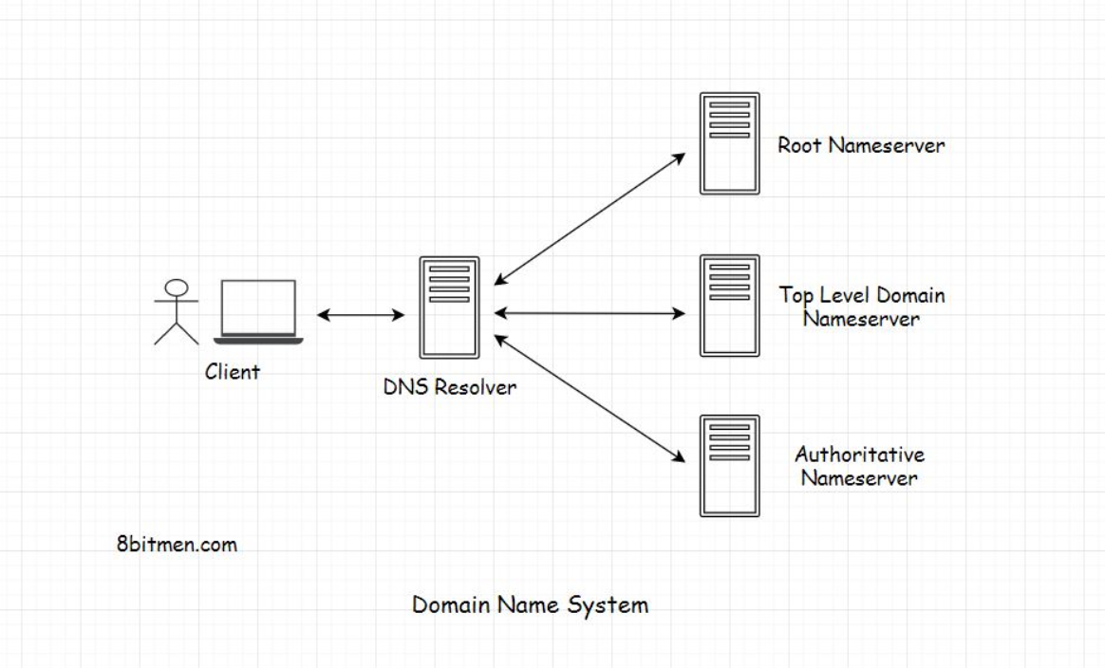  
  
  
  
DNS step by step implementation:  
  
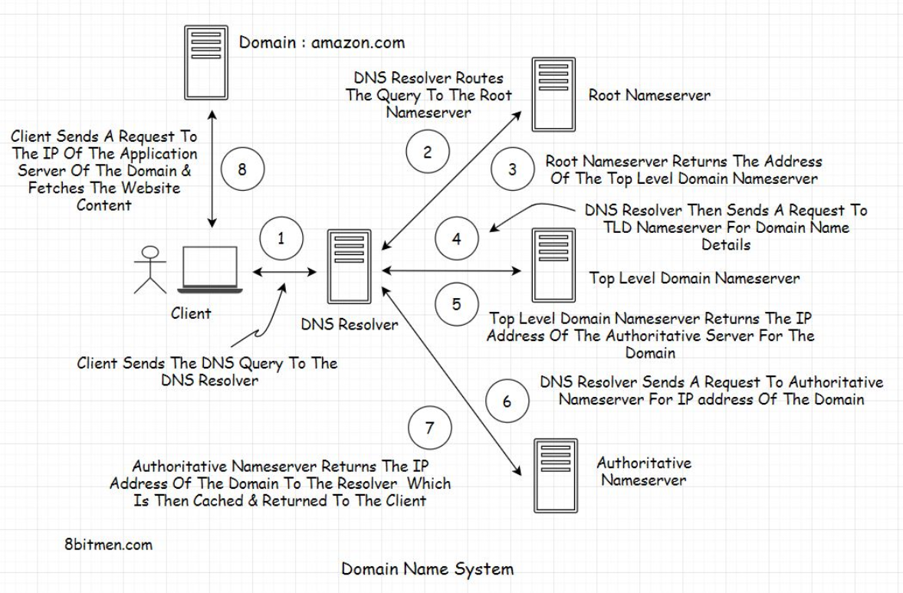

DNS Load Balancing:  
  
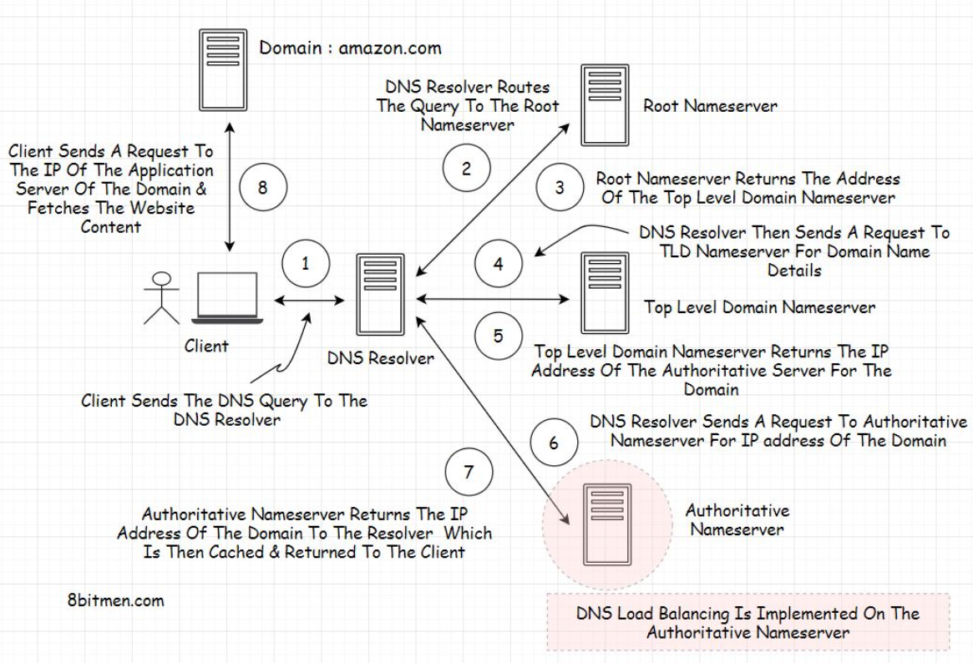

**Quorum:**  
  
In Distributed Systems, data is replicated across multiple servers for fault tolerance and high availability. Once a system decides to maintain multiple copies of data, another problem arises: how to make sure that all replicas are consistent, i.e., if they all have the latest copy of the data and that all clients see the same view of the data?

**Leader and Follower:**Distributed systems keep multiple copies of data for fault tolerance and higher availability. A system can use quorum to ensure data consistency between replicas, i.e., all reads and writes are not considered successful until a majority of nodes participate in the operation. However, using quorum can lead to another problem, that is, lower availability; at any time, the system needs to ensure that at least a majority of replicas are up and available, otherwise the operation will fail. Quorum is also not sufficient, as in certain failure scenarios, the client can still see inconsistent data.

